Project INSIEME – Reference Model Template
Task 04 - Grid Flexibility

CONTEXT:
- [TODO] If possible, please write explanations like recitals.
CHAPTER I
Regarding GENERAL PROVISIONS
Issue 1
On subject matter and scope
- [IGNORE FOR NOW]
Issue 2
On definitions
For the purpose of this implementing regulation, the definitions in Article 2 of Directive (EU) 2019/944 [TODO and state that the definitions in other pieces of European Legislation] shall apply. In addition, the following definitions shall apply:
Warning: this set of procedures are pursuant to flexible connection agreement, rules-based flexibility or market based, acknowledging at this stage that the data exchanges have a lot of similarities from a command-and-control point of view, and possibly from a contractual point of view. However, the content of the message and stakeholders differ.
- “Flexible customer” means an individual system user engaged or willing to engage in a flexibility program.
- “Controllable Unit” means a single power-generating module and/or a single demand unit pursuant to Article 2(5) of [RfG NC 2.0] and Article 2(4) of [DC NC 2.0], or an ensemble of power-generating modules and/or demand units behind the same accounting point if these power-generating modules and demand units are commonly controlled by a single Power Control System.
- “Power Control System” means a system or a device, which can control or limit the power flows of one or several CUs, to ensure compliance with the performances required and certified in line with the applicable national framework. If required, the power control system should be able to receive or send information.
- “Flexibility program“ means a structured initiative or framework designed to leverage the flexibility from FCs or CUs to achieve specific objectives within the energy system. These programs are typically organized by system operators, service providers, or regulatory bodies to manage and optimize energy consumption and generation as well as avoid congestion. A flexibility program encompasses frameworks such as market-based flexibility monetization activities by an FSP, direct flexibility mechanisms operated by SOs such a Flexible Connection Agreements, or self-consumption, citizen energy sharing communities.
- “Controllable Unit Operator” means an entity in charge of remotely commanding and controlling CUs and sending and receiving all relevant information and command/control signals to do so.
- “Flexibility event” means the end-to-end series of operations and information exchanges pursuant to a given Flexibility program in which a Technical Aggregator orchestrates the activation of CUs with the relevant stakeholders. The flexibility event involves the transmission of a flexibility request or a flexibility offer, an activation message, and the real-time observability, and later settlement with system users.
- “Digital customer interface” means a communication link that enables data exchange between network operators (DSOs) and customers or their controllable units. It plays a central role in the integration of controllable units.
- “Digital Customer Interface Operator” means …
Needed ?
- “Technical Aggregator” means an entity responsible for orchestrating a flexibility program on behalf of on or several flexible customers and monitoring their performance over time.
- “Flexibility program facilitator” means an entity representing / aggregating several system users (such as citizen energy community, owner of EV charging points in a parking of a housing complex…) or a flexibility service provider

Abbreviations
- The CU is the Controllable Unit
- The CSO is the connecting system operator
- The CUO is the Controllable Unit operator
- The FC is the Flexible customer

CHAPTER II
Regarding [YOUR USE CASE]

[NOTE] Typically define responsibilities last and in close coordination with T5.5 EU Policy and regulation alignment

Article XX
On responsibilities of ROLE1

- ROLE1 shall …

ANNEX A
A1. The reference model for Flexible Connection Agreement and Temporary Limits set at SPU, SPG or parts of SPG level (pursuant to Network Code Demand Response or in the context of any Flexibility Program)
Table I contains information needed by [Stakeholder1 AND Stakeholder2] to set up for utilising Flexible Connection Agreement and Temporary Limits set at SPU, SPG or parts of SPG level (pursuant to Network Code Demand Response or in the context of any Flexibility Program) in a Member State.
Table I - General information on Member State environments
ID | Name | Description
I1 | [EXAMPLE] National competent authority
  Name | Name of appointed national competent authority.
  Website | Website of appointed national competent authority.
  Official contact | Contact details for managing the mappings of national practices.
I2 | Digital Customer Interfaces employed | Note: Please keep in mind that for each DCI Procedure 1 must be mapped.
  Name | Name of the digital customer interface.
  Link | URL of a website containing documentation on the DCI
  Mode | In-cloud, on-premise or other (please describe)
  Data exchange standards | Documentation of standards and interfaces used for the communication with connecting system operators and other relevant actors.
I2 | [EXAMPLE] Information about permission administrators in a Member State  (at least one mapping per each active consent administrator in a Member State)
  Name | Name of the organisation.
  Type of identification | May be ACER registration code, Legal Entity Identifier (LEI), Bank Identifier Code (BIC), Energy Identification Code (EIC), Global Location Number (GLN/GS1) or National Identification Code (NIC).
  Identification of organisation | Code or identification within the identification space nominated above.
  Website | If applicable, link to website of a web application that is used for consent administration.
  User inface | URL or user portal.
  Official contact | Contact details for data sharing.
  Consent management responsibility for | Metered data administrators for which the consent administrator manages consents. Note that it is also valid for a metered data administrator to utilize several consent administrators for a consent administrator to act for multiple metered data administrators.
  Documentation of access | A self-sufficient explanation of the Member State provisions with regards to utilize access to validated historical consumption data by an eligible party. It is recommended to also include an English version of this documentation.
  Identity service provider | Identity service provider utilized by the consent administrator to authenticate final customers.
  Eligible party onboarding | Either a link to the English documentation of the onboarding procedure or a complete, self-sufficient English explanation for how an eligible party can onboard to the productive environment to utilize sharing of validated historical consumption data with an eligible party.
  Eligible party test onboarding | If applicable, either a link to the English documentation of the onboarding procedure or a complete, self-sufficient English explanation for how an eligible party can onboard to a test environment to utilize sharing of validated historical consumption data with an eligible party.
  Price list for access to data by eligible parties | Exhaustive description of all costs for eligible parties.
[TODO] Please describe all HARMONISED ROLES below.
Table II - Roles
Role name | Role type | Role description
Flexible Customer | Business | A party connected to the grid that is engaged or willing to engage in a flexibility program.  From Implementing Act on Demand Response  As defined in Article 2(3) of Directive (EU) 2019/944.  This refers to a party connected to the grid that purchases electricity for its own use.  Note: this also includes the case of active customer and participants of renewable energy communities or citizen energy communities
Connecting System Operator (also listed Connecting SO) | Business | A system operator operating the network where a customer is connected  From Implementing Act on Demand Response
CU Operator (also listed CU operator)  Also named Technical Aggregator | Business | A third party operating the CU delegated by the final customer to command and control the Controllable Units on the final customer premises which enables or orchestrates the participation of the final customer in a flexibility program  To be checked: consistency with Implementing Act on Demand Response
Digital Customer Interface Operator | Business | From Implementing Act on Demand Response

All roles of type Business are expected to be acting in secure, authenticated manner and through trusted communication channels. For this reason, the authentication steps used for these communication partners are not listed in the scenarios below.

Table III –Procedure Conditions
No. | Procedure name | Primary actor | Pre-condition
1 | Initialization of digital customer interface | DCI operator | The DCI Operator has physical/virtual access to the DCI hardware or service.
2 | Onboarding of a Flexible Customer to FCA in the Digital Customer Interface | CU operator | System user having (or planning to have) a CU on its premises and willing to engage in a flexibility program  List of prequalified CU operators made available by the Connecting SO (see Implementing Act on Demand Response)  CU Operator is onboarded (see Implementing Act on Demand Response)
3 | Termination of a flexible connection agreement by the connecting SO | Connecting SO | A final customer is onboarded to a flexible connection agreement.
4 | Revocation of a flexible connection agreement by the final customer | Final customer | A final customer is onboarded to a flexible connection agreement
5 | Activation or limitation of flexibility | Connecting SO | CU Operator operating the CU of one or several flexible customers  The CU Operator defines and sends per CU the default value of intake / outtake to its (safe state) (consistent with guaranteed capacity for connection agreement)

Procedure 1 – Initialization of digital customer Interface
Procedure 1 – Initialization of digital customer Interface
Step No. | Step | Step description | Information producer (actor) | Information receiver (actor) | Information exchanged (IDs)
1.1 | Execute Digital Customer Interface (pre-condition) | The DCI Operator (final customer or Technical Aggregator) installs and configures the means to communicate directly or indirectly with the Connecting SO. This may be on‑premise or cloud‑based.  Pre-Condition: The DCI Operator has physical/virtual access to the DCI hardware or service.  Post-Condition: The DCI is operational and can initiate communication with the Connecting SO | DCI operator | n/a | -
1.2 | Request registration for Digital Customer Interface | During setup, the DCI generates or is assigned a unique identification string. This identifier is provided to the DCI Operator and forwarded to the Connecting SO for certification.  Pre-condition: The DCI is initialized and capable of generating or receiving an identifier.  Post-condition: The Connecting SO has received the DCI identification information. | DCI operator | (Digital) Connecting System Operator | 1-A – DCI identification information
1.3 | Validate DCI Registration Request | Connecting SO validates that the provided DCI identifier belongs to the final customer and/or to the DCI Operator. This includes checking data consistency and ensuring that contractual and master data are up to date. If applicable, the SO may issue digital credentials and certificates (e.g. PKI/X.509) to secure further interactions. In this step, the Connecting SO may employ authentication via eIDAS eID and eIDAS Trust Services (for public/private key creation and timestamp synchronisation). If validation fails, an error flow is triggered providing a meaningful indication to the requester.  Pre-condition: The Connecting SO has received the DCI identification information.  Post-condition: The DCI is validated and, if successful, certified credentials are issued; or an error message is sent to the requester. | (Digital) Connecting System Operator | DCI operator | 2-B – DCI certification information
1.4 | Execute the installation of the certified credential information (post condition) | The DCI Operator installs the certified credential information (e.g. Connecting SO‑signed authentication certificate) into the DCI.  Pre-condition: The DCI Operator has received valid certified credential information from the Connecting SO.  Post-condition: The DCI contains valid, certified credential information, enabling secure communication with the Connecting SO. | DCI operator | DCI operator | -

Table IV.1 - Information exchanged – Procedure 1 – Initialization of digital customer Interface
Information exchanged, ID | Name of information | Description of information exchanged
1-A | DCI identification information
  DCI identifier | Identifier used by the DCI in further communication
  Certification request | If applicable, a certification request string to be signed by the CSO as a trusted authority.
  Identifier of the final customer | Final customer identification to be understood by the connecting SO
  Identifier of the CU operator | If applicable and if different from the final customer, the identification of the CU operator
1-B | DCI certification information
  DCI identification information | 1-A provided for validation
  Confirmation result | Result of the step, e.g. to indicate success, or invalid data.
  Signed certificate | If applicable the signed certificate for the PKI keypair.
  CSO DCI identification | Identification of the DCI as registered at the CSO (for further communication).

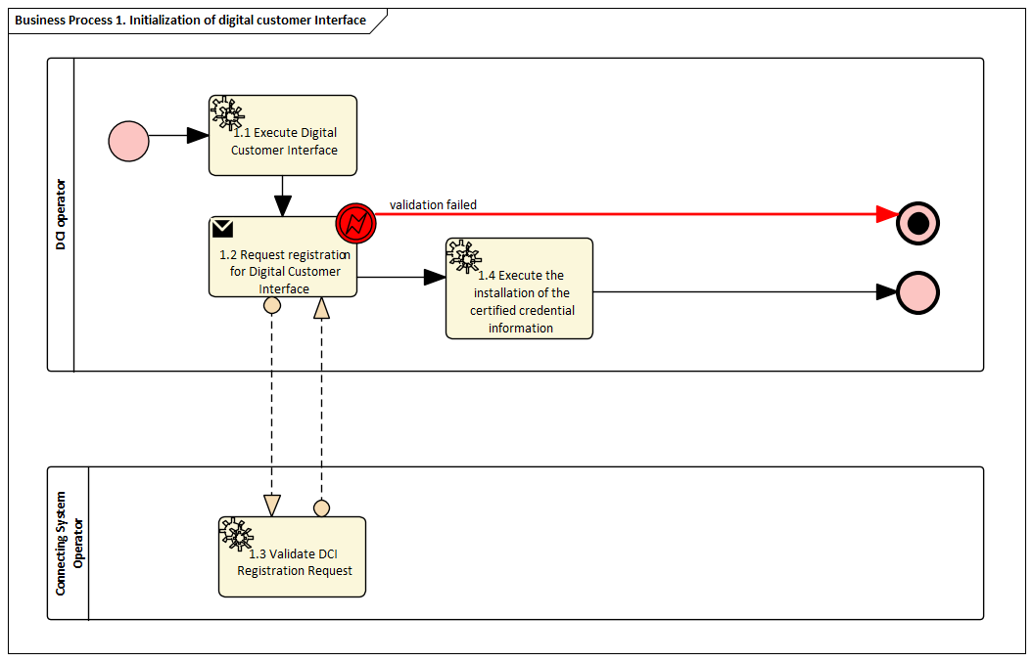
Diagram Procedure 1 – Setting up Digital Customer Interface

Procedure 2 – Onboarding of a flexible customer to FCA in the Digital Customer Interface

Procedure 2 – Onboarding of a Flexible Customer to FCA in the Digital Customer Interface
Step No. | Step | Step description | Information producer (actor) | Information receiver (actor) | Information exchanged (IDs)
2.1 | Request network connection | The final customer applies for a connection providing in particular power requirement attributes | Final customer | Connecting System Operator | 2-A Connection application
2.2 | Execute the connection application study | Connecting SO processes the connection request and defines the proposal to the Final Customer:  - a connection with firm capacity matching the customer request  - or 1 or several proposals for flexible connection agreements specifying the FCA conditions (if applicable);  - or refusal of connection (if applicable) | Connecting System Operator
2.3 | Request to sign connection proposal | Connecting SO sends the connection proposal to the Final customer  Nota: A « regular » connection proposal is consistent with 2-B FCA condition where flexible capacity is 0, time block is «always», and agreed duration of transitory phase is 0 | Connecting System Operator | Final Customer | 2-B FCA conditions
2.4 | Sign the connection proposal | The Final Customer  - accepts the connection proposal,  - or rejects its connection request (it can then restart process and apply for a different connection)  If the proposal consists in firm connection agreement à end of Harmonized Role Model description in this procedure, if no need for CU control or real-time access by Connecting SO  If Flexible Connection Agreement or need for CU control or real-time access, process follows next steps | Final Customer | Connecting System Operator | 2-C-Acceptance of connection proposal
2.5.a | (optional) Request near real time access | To enable operation of the network with FCA, Connecting SO may require access to near real time energy data access to the final customer | Connecting System Operator | Final Customer | 2-D Near real time data needed by Connecting SO
2.5.b | [if step above is implemented] Send consent for near real time data request | The final customer accepts or rejects access to the near real time energy data.  If rejects: termination of the connection proposal or limitation to only firm capacity (no flexible capacity), depending of the applicable connection framework | Final customer | Connecting System Operator | 2-E Customer consent for near real time data needed by Connecting SO
2.6 | Execute selection of CU Operator | The final customer will delegate FCA operation of his Controllable Unit to a CU Operator. He thus selects a CU Operator in the list of prequalified CU Operators provided by Connecting SO.  Precondition: Connecting SO defines and maintains a list of Prequalified CU Operators, and makes it available to Final Customers | Final customer
2.7 | Request CU operator to command and control its flexible assets | The final customer contacts the CU operator of its choice and forward data on its FCA conditions  Nota: A «regular» connection proposal is consistent with 2-B FCA condition where flexible capacity is 0, time block is « always », and agreed duration is 0 | Final customer | CU Operator | 2-B FCA conditions
2.8 | Send the service agreement for CU operation | The CU operator sends to the Final Customer a proposal for service provision  The service agreement for CU operation includes at least:  - consent for data sharing (data with CU Operator and data to be forwarded to the eligible parties) and command and control by CU operator  - mandate (representation contract) for CU operator to interact with Connecting SO on its behalf.  - Service level agreement  - Other Terms and Conditions | CU Operator | Final customer | 2-F- service agreement for CU operation
2.9 | Sign the service agreement for CU operation | The Final Customer accepts (or rejects) the service agreement for CU operation  If rejects: Customer needs to choose another CU operator | Final customer | CU Operator | 2-G- consent for service agreement for CU operation
2.10 | Send CU operator choice | The CU operator informs the Connecting SO on behalf on the Final Customer that it has been chosen as CU operator | CU Operator | Connecting System Operator | 2-H Chosen CU operator
2.11 | Send the Customer consent | The CU operator forwards the final customer consent to all eligible parties | CU Operator | Eligible parties | 2-I Customer consent to share and access data
2.12 | Send FCA technical properties + specifications for data exchange (if step 2.5.a is implemented) | Connecting SO makes available to the CU Operator all relevant characteristics of the FCA allowing him to technically enable its operation | Connecting System Operator | CU Operator | 2-J FCA technical specifications
2.13 | Execute CU Operation system configuration | The CU Operator instruments and configures the controllable unit and performs all technical prerequisites on the CU side and on behalf of the final customer to enable the commissioning of the FCA.  Comment: This step may be already or automatically done, for example when installing equipment (such as “plug and play” interfaces) | CU Operator
2.14 | Send confirmation of the end of CU configuration – operational readiness | The CU operator informs the Connecting SO it is ready to execute command and control of the CU of the Final Customer | CU Operator | Connecting System Operator | 2-K Operational readiness notification
2.15 | [optional] Notify Final Customer of successful Command and Control | Forward information to Final Customer | CU Operator | Final customer | 2-K operational readiness notification
2.16.a | (optional) Send information to prepare for the activation test | Connecting SO triggers an activation test of the FCA (procedure 5) and associated CU (operated by CU operator) to validate readiness for Business-as-usual FCA operation  Connecting SO would send in step 5.4 of procedure 5 information 5-C Limit notification or activation per Flexible Customer, or over an ensemble of Flexible Customers | Connecting System Operator | CU operator | 2-L information to prepare for the activation test  5-C Limit notification or activation per Flexible Customer, or over an ensemble of Flexible Customers
2.16.b | [if previous step is implemented] (optional) Send data required by activation test | The CU operator sends the data in the required optional steps of Procedure 5  - 5.1b 5-A Forecasted baseline intake / outtake  - 5.2b and 5.13.b 5-B near-real time intake / outtake  - 5.5 5-D Limitation / activation receipt notification of flexibility event  - 5.8 5-B forecasted / impact (power intake / outtake) due to the activation / limitation | CU operator | Connecting SO | If required in Procedure 5  5-A Forecasted baseline intake / outtake  5-B near-real time intake / outtake  5-D Limitation / activation receipt notification of flexibility event  5-B forecasted / impact (power intake / outtake) due to the activation / limitation
2.16.c | [if previous step is implemented] Validate the performance of the activation test and of the exchange of data | Connecting SO assesses whether the activation test is successful | Connecting System Operator
2.16.d | Send acknowledgement of the proper functioning of the FCA | Connecting SO informs the CU operator that the FCA performs as expected and authorizes commissioning of FCA.  If it does not function as expected, a new activation test may be performed (go to step 2.13) or the FCA is invalidated. | Connecting System Operator | CU Operator | 2-L Activation test result confirmation
2.16.e | Notify Final Customer of successful Command and Control | Forward information to Final Customer | CU Operator | Final customer | 2-M Activation test result confirmation
2.17 | Send Final Customer confirmation of Commissioning Authorization | Connecting SO confirms to the Final Customer that its FCA can be commissioned | Connecting System Operator | CU operator | 2-N FCA Commissioning authorization

Table IV.2 - Information exchanged – Procedure 2 – Onboarding of a Flexible Customer to FCA in the Digital Customer Interface
Information exchanged, ID | Name of information | Description of information exchanged
2-A | Connection application | - Power  - (Optional) Type of CU  - (Optional) Connection Point identifier  - (Optional) Requested power per time block
2-B | FCA conditions | - Maximum capacity (in both directions (guaranteed and flexible) by time block  - Agreed duration (expected date for granting connection to the entire requested firm capacity)  - Applicable Network charges  - (optional): Minimum intake/outtake when FCA is activated  - (Optional) Additional contractual information  - (Optional) need for near real-time data  - (Optional) Need for forecast of power intake / outtake  - Safe-state setpoint (minimum guaranteed connection capacity) in case of loss of communication
2-C | Acceptance of connection proposal | Y / N
2-D | Near real time data needed by Connecting SO | Request for technical data (referred to procedure 5 information object 5-B) specifying at least latency and periodicity
2-E | Customer consent for near real time data needed by Connecting SO | Y / N
2-F | Service agreement for CU operation | - Consent for data sharing (data with CU Operator and data to be forwarded to eligible parties) and consent for command and control by CU operator  - Mandate (representation contract) for CU operator to interact with Connecting SO on behalf of the Fina Customer.  - Service level agreement  - Other Terms and Conditions
2-G | Consent for service agreement for CU operation | Consent (Y/N)
2-H | Chosen CU Operator | ID of CU Operator
2-I | Customer consent to share and access data | List of data associated with customer consent
2-J | FCA technical specifications | 2-B + 2-D  Technical parameters such as latency, frequency  Connectivity information (such as IP address, )
2-K | Operational readiness notification | Ready
2-L | Information to prepare for the activation test | To be defined
2-M | Activation test result confirmation | Successful / Failed  Authorized /
2-N | FCA Commissioning authorization | Authorized firm capacity  Authorized Flexible capacity

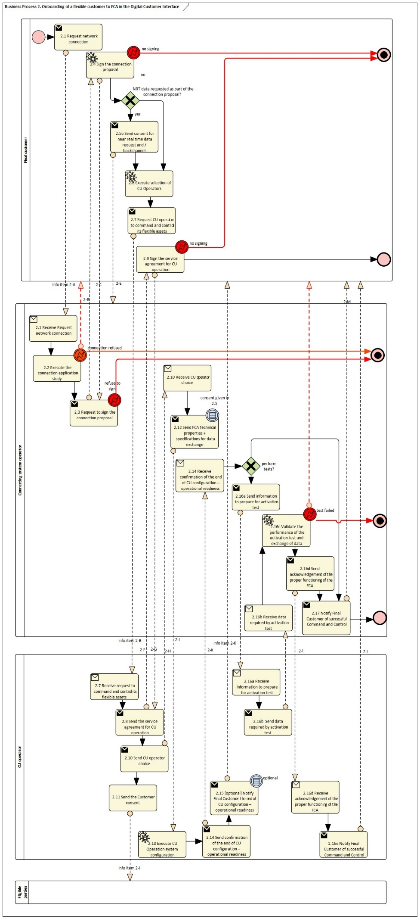

- Procedure 3: Revocation of a flexible connection agreement by the final customer

Procedure 3 – Revocation by a Final Customer of a FCA in the Digital Customer Interface
Step No. | Step | Step description | Information producer (actor) | Information receiver (actor) | Information exchanged (IDs)
3.1 | Request for revocation | The final customer requests for a revocation of the flexible connection agreement | Final customer | Connecting System Operator | 3-A Revocation request
3.2 | Validation of the revocation | Connecting SO validates the request for final revocation | Connecting System Operator | Final Customer | - 3-B Revocation validation
3.3 | (optional) Send new connection conditions | Connecting SO informs the final customer about the new (fallback) connection agreement  Nota: The fallback conditions may have been defined at the time of the FCA proposal | Connecting System Operator | Final Customer | 3-C New (fallback) contractual conditions: same as 2-B except no information on agreed duration
3.4 | Validation of the new connection condition | The final customer validates the new connection condition | Final customer | Connecting System Operator | 3-D New (fallback) connection validation
3.5.a (optional) | Send the new connection conditions to Controllable Unit Operator | If there is still a need for a CU operator (need to command and control CU to ensure compliance with firm capacity, or need to provide forecast or near-real time data), the Connecting SO informs the CU operator about the revocation and the new connection conditions | Connecting System Operator | Controllable Unit Operator | 3-E Information Object (same as 2-J FCA technical specifications)
3.5.b | Acknowledge revocation | The CU operator acknowledges the revocation of FCA | Controllable Unit Operator | Connecting System Operator | 3-F Acknowledgment

Table IV.3 - Information exchanged – Procedure3 Revocation of a flexible connection agreement by the final customer
Information exchanged, ID | Name of information | Description of information exchanged
3-A | Revocation request | - Capacity (in both directions) by time block  - (Optional) Type of CU  Connection Agreement Point identifier
3-B | Revocation validation | - Consent (Y/N)
3-C | New (fallback) contractual conditions | - Capacity (in both directions) by time block  - Applicable Network charges  - (Optional) Additional contractual information  - (Optional) need for near real-time data  - (Optional) Need for forecast of power intake / outtake  - Safe state setpoint (minimum guaranteed connection capacity) in case of loss of communication  - (optional) alternatives  Same as 2B excepts no information on agreed duration
3D | New (fallback) connection validation | Consent (Y/N) or alternative chosen (if implemented)
3-E | Technical specifications of Connection Agreement | Same as 2-J Technical specifications of Connection Agreement
3-F | Acknowledgement | Received
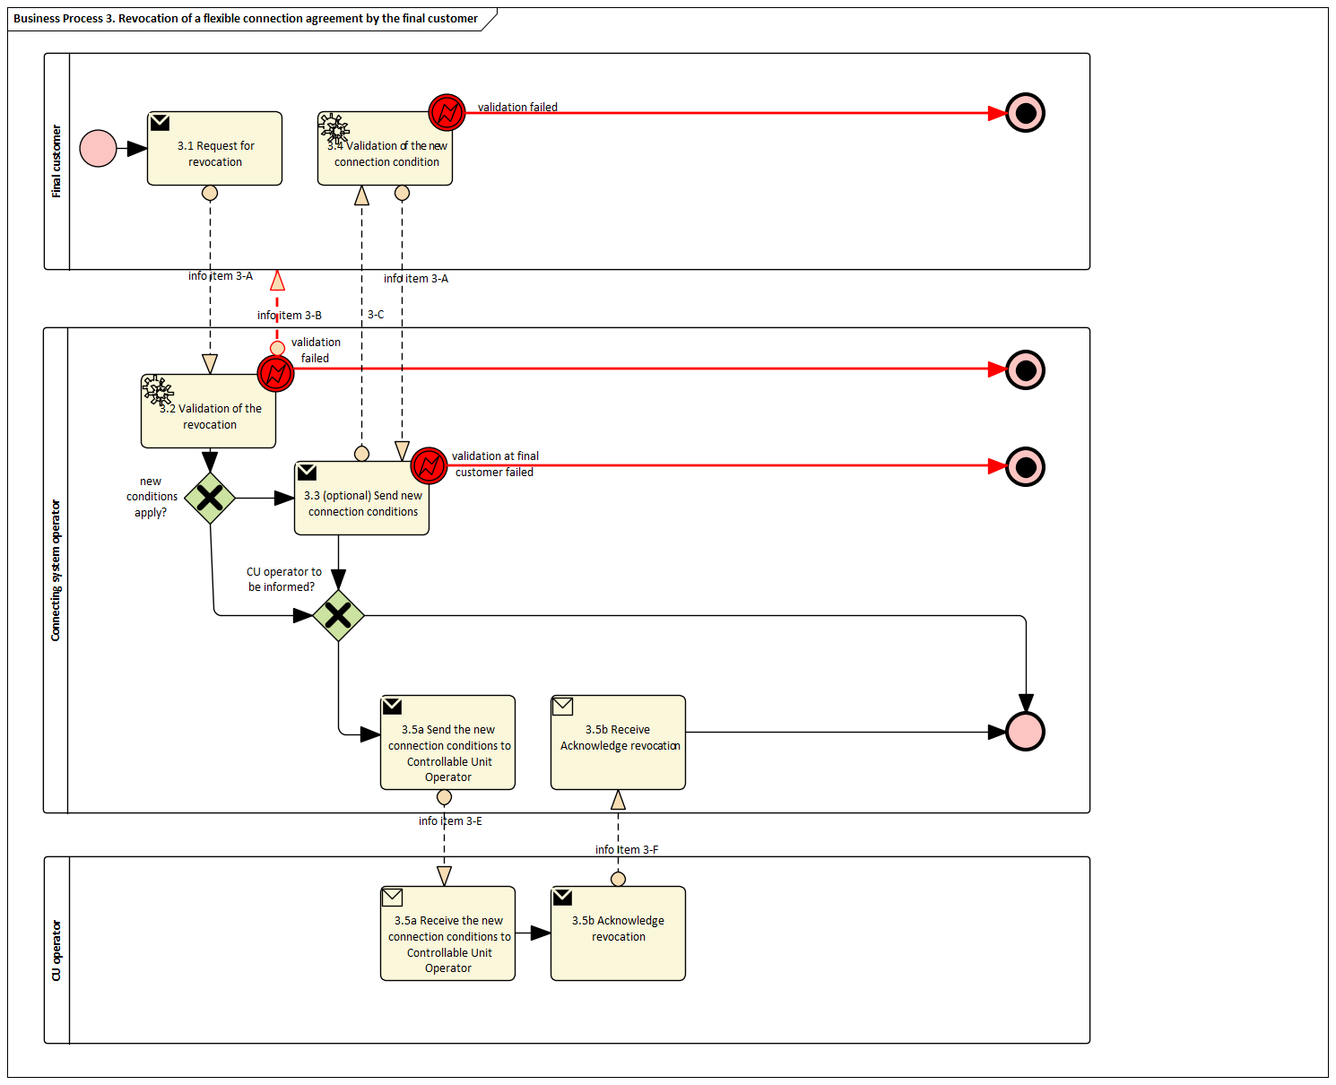
- Procedure 4: Termination of a flexible connection agreement by the connecting SO

Procedure 4 – Termination by a Connecting System Operator of a Final Customer to FCA in the Digital Customer Interface
Step No. | Step | Step description | Information producer (actor) | Information receiver (actor) | Information exchanged (IDs)
4.1 | Send final customer information about termination of FCA | Connecting SO informs the final customer about termination of FCA | Connecting system Operator | Final Customer | 4-A Termination information
4.2 | Send new connection conditions | Connecting SO informs the final customer about the new connection conditions | Connecting System Operator | Final Customer | 4-B New (fallback) contractual conditions (same as 3-C)
4.3 | Acknowledge new connection conditions (including if implemented choice of alternative) | The Final Customer acknowledges the new connection conditions (or chooses a proposed alternative) | Final Customer | Connecting System operator | 4-C New (fallback) connection acknowledgement
4.4 | Send information about termination of FCA to Controllable Unit Operator | Connecting SO informs the CU operator about termination of the FCA | Connecting System Operator | Controllable Unit Operator | 4-C Information Object
4.5 (optional) | Send the new connection conditions to Controllable Unit Operator | If there is still a need for a CU operator (need to command and control CU to ensure compliance with firm capacity, or need to provide forecast or near-real time data), Connecting SO informs the CU operator about the termination and the new connection conditions | Connecting System Operator | Controllable Unit Operator | 4-D Technical specifications of Connection Agreement (same as 2-J and 3-E)
4.6 | Acknowledge termination of FCA | The CU operator acknowledges termination of FCA (+ if 4.5 is implemented reception of new connection agreement conditions) | Controllable Unit Operator | Connecting System Operator | 4-E Acknowledgment

Table IV.4 - Information exchanged – Procedure 4 –Termination of a FC to FCA in the Digital Customer Interface
Information exchanged, ID | Name of information | Description of information exchanged
4-A | Termination information | - Information object
4-B | New (fallback) contractual conditions | Same as 3-C  - Capacity (in both directions (guaranteed) by time block  - Applicable Network charges  - (Optional) Additional contractual information  - (Optional) Need for near real-time data  - (Optional) need for forecast of power intake / outtake  - (optional) alternatives  - (Optional) Type of CU  - Optional) Connection Agreement Point identifier
4-C | Information object | - Same as 4-E
4-D | Technical specifications of Connection Agreement | same as 2-J and 3-E:  - Capacity (in both directions (guaranteed) by time block  - Applicable Network charges  - (Optional) Additional contractual information  - (Optional) Near real-time needed data  - (Optional) Forecast of power intake / outtake  - (optional) alternatives  - (Optional) Type of CU  - Optional) Connection Agreement Point identifier
4-E | Acknowledgement | Received
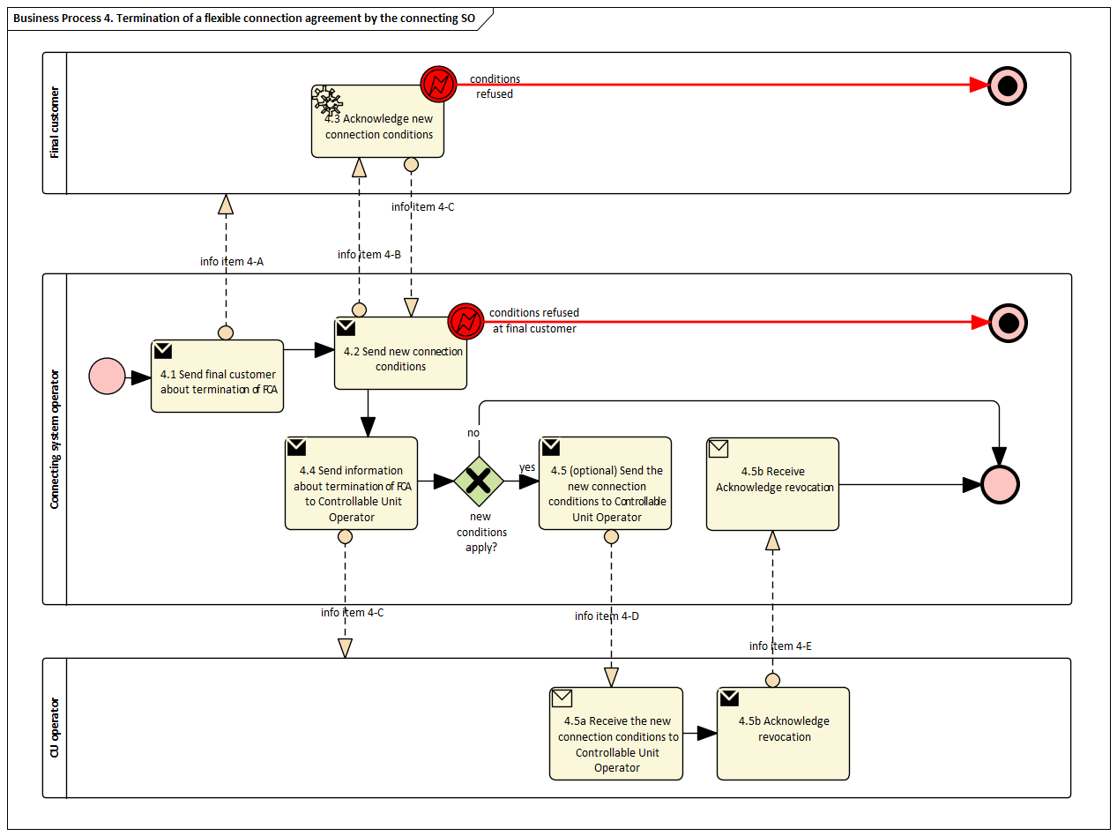
Missing here a procedure : if final customer revokes (likely to provoke the end of FCA) or switches CU operator (likely same as onboarding in FCA at the step of selecting CU operator – in the meantime, capacity may be limited to guaranteed capacity only)
- Procedure 5: Activation / limitation of Flexibility event

Procedure 5 – Activation / limitation of Flexibility event
Step No. | Step | Step description | Information producer (actor) | Information receiver (actor) | Information exchanged (IDs)
5.1.a | (optional) Execute computation of the forecasted baseline intake / outtake | The CU Operator computes (or updates) forecasted baseline intake / outtake for each Final Customer or ensemble of Final Customer (FCA, SPU, SPG or part of SPG) (if there is no activation/limitation) | CU Operator
5.1.b | [if previous step is implemented] (optional) Send forecasted baseline intake / outtake | The CU Operator sends the forecasted baseline intake / outtake for each Final Customer or ensemble of Final Customers (FCA, SPU, SPG or part of SPG). | CU Operator | Connecting System Operator and eligible parties | 5-A Forecasted baseline intake / outtake
5.2.a | (optional) Execute computation of the near-real time intake / outtake | The CU Operator computes (or updates) near-real-time intake / outtake for each Final Customer or ensemble of Final Customer (FCA, SPU, SPG or part of SPG) (if there is no activation / limitation)
5.2.b | [if previous step is implemented] (optional) Send near-real time intake / outtake | The CU Operator sends the near-real-time intake / outtake for each Final Customer or ensemble of Final Customer (FCA, SPU, SPG or parts of SPG) (if there is no activation/limitation) | CU Operator | Connecting System Operator and eligible parties | 5-B near-real time intake / outtake
5.3 | Execute computation of activation / limitation of a flexibility event per Final Customer or ensemble of Final Customers | Connecting SO computes (or updates) the activation / limitation of a flexibility event for each Final Customer or ensemble of Final Customers pursuant to a provision in the connection agreement between itself and each Final Customer (or other relevant framework). | Connecting System Operator | not applicable | not applicable
5.4 | (optional) Send forecast of possible activation / limitation per Final Customer or ensemble of Final Customers | Connecting SO sends forecasts of requested activation / limitation for each Final Customer or ensemble of Final Customers (FCA, SPU, SPG or part of SPG  Nota: Connecting So may be able to inform the Cu operator in advance of a possible activation / limitation later on. | Connecting System Operator | CU operator | 5-C Limit notification or activation per Flexible Customer, or over an ensemble of Flexible Customers
5.5 | Send activation / limitation per Final Customer or ensemble of Final Customers | Connecting SO sends the requested activation / limitation for each Final Customer or ensemble of Final Customers (FCA, SPU, SPG or part of SPG). | Connecting System Operator | CU Operator | 5-C Limit notification or activation per Flexible Customer, or over an ensemble of Flexible Customers
5.6 | (optional) Acknowledge the activation / limitation of a flexibility event | The CU Operator acknowledges the activation / limitation back to the Connecting SO | CU Operator | Connecting System Operator | 5-D Limitation / activation receipt notification of flexibility event
5.7 | Notify eligible parties (e.g. suppliers, BRPs…) | Connecting SO notifies all affected parties regarding the activation / limitation of the Final Customer (s). | CU Operator | Eligible parties | Same as 5-C
5.8 | Execute the allocation of activation / limitation per site & CU, and the computation of the forecasted impact (power intake / outtake) per Final Customer or ensemble of Final Customers | The CU Operator computes (or updates)  - The activation or limitation per site and per CU to comply with the activation / limitation of a flexibility event per Final Customer or ensemble of Final Customers  - the forecasted impact (power intake / outtake for each Final Customer or ensemble of Final Customers (FCA, SPU, SPG or part of SPG) | CU Operator
5.9 | (optional) Send forecast / impact (power intake / outtake) due to the activation / limitation | The CU Operator sends forecasted / planned impact (power intake / outtake for each Final Customer or ensemble of Final Customers (FCA, SPU, SPG or part of SPG)) due to the activation / limitation | CU Operator | Connecting System Operator + eligible parties | Same as 5-B
5.10 | Send the activation per Final Customer and CU | The CU operator activates or limits each CU | CU operator | CU | 5-E CU limit / activation notification
5.11 | Acknowledge the activation / limitation at CU level | The CU acknowledges the activation / limitation back to the CU operator | CU | CU operator | 5-F Limitation / activation receipt notification at CU level
5.12 | Execute CU limit to default value (safe state mode) in case of communication failure | If the CU limit has not received any communication from the CU operator since a given delay (x min or hours), the CU is automatically limited to the default (safe state) value. | CU
5.13 | (optional) Notify eligible parties (e.g. Final Customer, affected service providers) about CU activation / limitation | The CU Operator notifies all affected parties that need to be informed that an activation / limitation has been received and split per site & CU. | CU Operator | Eligible parties | Same as 5-E
5.14.a | (optional) Execute computation of the near-real time intake / outtake | The CU Operator computes (or updates) near-real-time intake / outtake for each Final Customer or ensemble of Final Customer (FCA, SPU, SPG or part of SPG) (if there is no activation / limitation)
5.14.b | (optional) Send near-real time intake / outtake | The CU Operator sends the near-real-time intake / outtake for each Final Customer or ensemble of Final Customer (FCA, SPU, SPG or part of SPG) (if there is no activation/limitation) | CU Operator | Connecting System Operator and eligible parties | 5-B near-real time intake / outtake

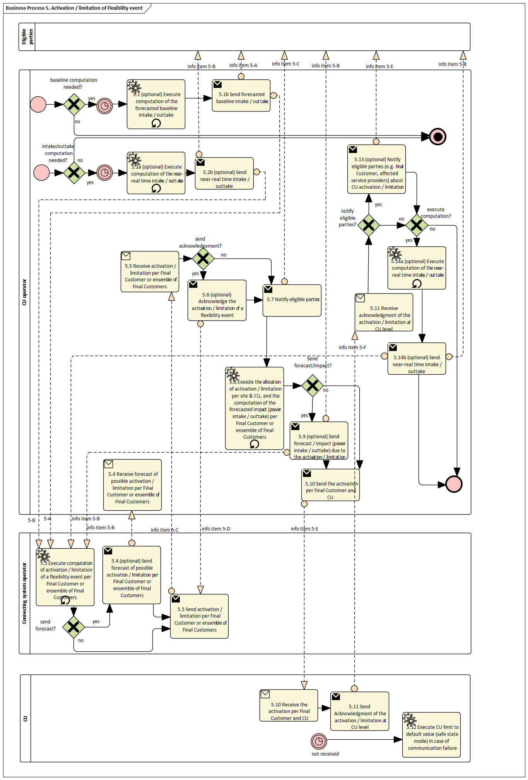
Important note:
This procedure loops: steps 5.13.a and 5.13.b are the same as steps 5.2.a and 5.2.b.

This procedure considers a single CU operator per site, which will be the case for the overwhelming majority of Final Customers.
The limitations set by Connecting SO must be respected by the Final Customer, regardless the number of CU Operators active within its premises.
If there are several CU operators active on premises, the Final Customer shall designate a “Master CU Operator” which will be responsible for ensuring the respect of any limitation /activation order set by a Connecting SO on the Final Customer i.e. allocating the flexibility activated or limited at the connection / connection agreement point among all CU Operators that are active within the Final Customer premises, that is the Master CU Operator and all subsequent CU Operators. In such a case, procedure 5 would need to be adapted where the Master CU Operator would send orders or limitations directly to its own CU, or per System user to other all subsequent CU Operators, which in turn will send orders or limitations to their own CUs.
An allocation rule should be defined by the Final Customer, such as priority to activate assets or priority to not activate assets.
Additional rules should be defined, specifying whether the master CU operator is eligible to know the identity of subsequent CU operator or whether they should be anonymized, rules if there is incompliance of a subsequent CU operator and so forth. Such rules, procedures and data exchange would be complex and difficult to streamline.
This procedure considers a single CU operator per site, which will be the case for the overwhelming majority of Final Customers.

Table IV.5 - Information exchanged: Procedure 5 – Activation or limitation of flexibility event
Information exchanged, ID | Name of information | Description of information exchanged
5-A | Forecasted baseline intake / outtake | Time series of active / reactive power in both directions
5-B | Near real time intake / outtake | Actual power (active / reactive)
5-C | Limit notification or activation per Flexible Customer, or over an ensemble of Flexible Customers | - Maximum Active / reactive Power in one or both directions  - Time frame (start time / end time)  - (Optional) Minimum active / reactive power in one or both directions  - (Optional) Legal or contractual provision pursuant to the limitation or activation  - Identification of the Flexible Customer, or the ensemble of Flexible Customers
5-D | (Optional) Limitation / activation receipt notification of flexibility event | - (Optional): yes, I have received and can comply  - (Optional): yes, I have received and cannot comply
5-E | CU limit / activation notification at CU level | - Maximum and/or minimum Active / reactive Power in one or both directions  - Time frame (start time / end time)
5-F | (Optional) Limitation / activation receipt notification at CU level | - (Optional): yes, I have received and can comply  - (Optional): yes, I have received and cannot comply

Missing procedures:
- Onboarding of local services: provided by NCDR
- Onboarding of energy communities: provided by Task 4.3
- Procedures for back office and settlement to be reviewed and adapted from the procedures for Network Code Demand Response

